Project in
AIU Coursera Courses Management System

Instructor: Dr. Laila Shokry

Student name: Tasneem Ibrahim Hassan Mohamed Taha

Student’s ID: 22101382
22101925
Faculty: Computer science and engineering (CSE)
Level: Two
Semester: spring 2024

Course name: Database systems Course Code: CSE22I

Phase I

Application Description

Identifying project application:
The AIU Coursera Course Management System is designed to track and manage courses offered by Coursera platform to AIU University. This system facilitates and organize the system between AIU instructors, students and Coursera courses. By allowing the instructor of each course to invite the students registered in the course and following his students by their weekly report that is generated automatically by DBMS and shows the data that each instructor and student need.
Data needed for the system:
System needs to store some data about the instructor (email, name, ID) and some data about the students (email, name, ID, level, semesterNo)

- Business rules
- Each AIU course can be associated with at least one Coursera courses.
- Each Coursera course has a unique link slug.
- Instructors can map Coursera modules to specific weeks of their AIU courses.
- Automatically generated weekly report that must contains :
.Total number of students invited or removed by the instructors in each field, and total number of students all over the university.
.Total number of students that enroll courses and complete them in each field, and in whole university.
.All students that haven’t enrolled in any course in Coursera to remove them.
.At the end of the semester we need the total of the semester of these numbers per field and the total for AIU.
- At the end of each semester and year, comprehensive reports must be generated summarizing student enrollment and completion data.
- AIU instructors can only see their own courses and the Coursera courses that were previously used in their courses.
- The main Coursera coordinator has access to all data and reports in the system.
- Instructors must be added as an admins and got an admin link to the program of their major to allow them to invite their students to their courses.
- Guided projects can be added to one or two weeks in the AIU course schedule.

- Students should be removed from the system if they complete their Coursera courses or if they do not enroll in any courses for an extended period (limited duration).

- Queries
- Which AIU courses have the highest number of enrolled students this semester? Can you provide the course names and enrollment figures?
- What is aiu courses that used coursera before in one of the previous semesters? Provide which courses were used and mention all their information if there is?
- Which Coursera programs exist for each AIU field? Can you provide details on these programs, including their admin and learner links?
- What is the total number of Coursera licenses needed for each field per semester?
- How do we calculate the overlap percentage between AIU course materials and Coursera modules? Can you describe the methodology used for this calculation?
- At the start of each semester, what information do we need to include in the report for each AIU field? Can you specify the required details?
- How do we determine the number of AIU courses that have requested Coursera for the current semester? Can you outline the process for identifying these courses?
- What are the specific data points we need to capture for each course in the report? Can you provide a breakdown of the required course details, including course codes, number of students enrolled, and duration of Coursera licenses?
- How do we categorize students based on their levels in the report? Can you explain the criteria used to determine student levels?
- What is the process for calculating the total number of students who will use Coursera throughout each of the 16 semester weeks? Can you describe the methodology for this calculation?
- On a weekly basis, how do we determine which students need to be added to Coursera based on the available licenses? Can you explain the process for identifying these students and ensuring that there are enough licenses remaining?
- What is the process for uploading the student lists to OneDrive as CSV files? Can you outline the steps for accessing and utilizing these files for adding students to Coursera?
- For the weekly report, how do we calculate the total number of students invited from each field and the number of students removed? Can you provide the process for obtaining these figures for each field individually and for all fields combined? And what is the procedure for determining the total number of enrolled students and completions for each field in the weekly report? Can you explain how these numbers are aggregated and presented in the report?
- If the reports are not generated automatically, how do users query the database for this information afterwards? Can you describe the querying process and the access privileges for different user roles, including the main Coursera coordinator, field coordinators, and instructors?

Phase II
EERD
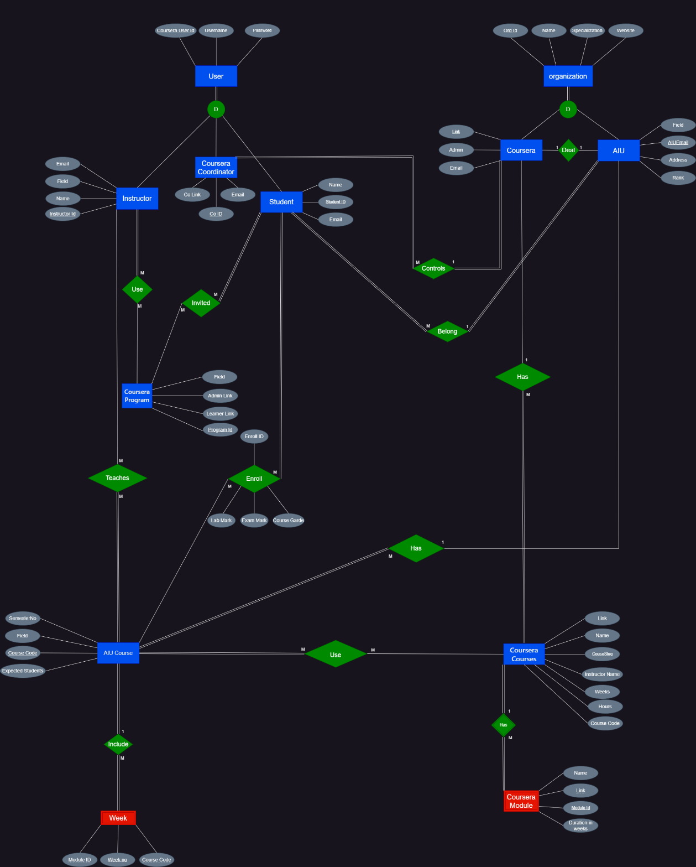
Phase III

- Step 1: Relational schema

- User (CourseraUserID, Username, password)
- Organization (OrgID, Name, Specialization, Website)
- Coursera (CLink, OrgID (FK for organization), Admin, Email)
- AIU (AIUEmail, OrgID (FK for organization), Clink (FK for Coursera), Field, Address, Rank)
- AIUCourses (CourseCode, AIUEmail (FK for AIU), SemesterNo, Field, StudentsNo)
- CourseraCourses (Slug, Clink (FK for coursera), Link, Name, Instructor, CCode, weeks, hours)
- Use (CourseCode (FK for AIU Courses) , Slug (FK for Coursera Courses)
- Instructor (InstructorID, UserID (FK for User), Email, Field, Name)
- Teaches ( InstructorID (FK for instructor), CourseCode (FK for AIU Courses))
- Coursera Program (ProgramID, Field, AdminLink, LearnerLink)
- Use ( InstructorID (FK for instructor), ProgramID (FK for Coursera Program))
- Student (StuID, UserID (FK for User), AIUEmail (FK for AIU), Name, Email)
- Invite (StuID (FK for student), ProgramID (FK for Coursera Program))
- Enroll (EnrollID , StuID (FK for student), CourseCode (FK for AIU Courses) ,LabMark, ExamMark, CourseGrade)
- CourseraCoordinator (CoID, UserID (FK for User), Clink (FK for coursera), CoLink, Email)
- Coursera Module (ModuleID, Slug (FK for Coursera courses), Name, Duration)
- Week (WeekNo, ModuleID (FK for Module), CourseCode (FK for AIU courses))

2. Step 2: First Normal Form (1NF)

- User Table:
- CourseraUserID (PK)
- Username
- Password
CourseraUserID | Username | Password

- Organization Table:
  - OrgID (PK)
  - Name
  - Specialization
  - Website
OrgID | Name | Specialization | Website

- Coursera Table:
  - CLink (PK)
  - OrgID (FK for Organization)
  - Admin
  - Email
Clink | OrgID | Admin | Email

- AIU Table:
  - AIUEmail (PK)
  - OrgID (FK for Organization)
  - Clink (FK for Coursera)
  - Field
  - Rank
  - Address
AIUEmail | OrgID | Clink | Field | Rank | Address

- AIUCourses Table:
  - CourseCode (PK)
  - AIUEmail (FK for AIU)
  - SemesterNo
  - Field
  - StudentsNo
CourseCode | AIUEmail | SemesterNo | Field | StudentsNo

- CourseraCourses Table:
  - Slug (PK)
  - Clink (FK for Coursera)
  - Link
  - Name
  - Instructor
  - CCode
  - weeks
  - hours
Slug | Clink | Link | Name | Instructor | CCode | weeks | hours

- Use Table:
  - CourseCode (FK for AIU Courses)
  - Slug (FK for Coursera Courses)
CourseCode | Slug

- Instructor Table:
  - InstructorID (PK)
  - UserID (FK for User)
  - Email
  - Field
  - Name
InstructorID | UserID | Email | Field | Name

- Teaches Table:
  - InstructorID (FK for instructor)
  - CourseCode (FK for AIU Courses)
InstructorID | CourseCode

- Coursera Program Table:
  - ProgramID (PK)
  - Field
  - AdminLink
  - LearnerLink
ProgramID | Field | AdminLink | LearnerLink

- Use 2 Table:
  - InstructorID (FK for instructor)
  - ProgramID (FK for Coursera Program)
InstructorID | ProgramID

- Student Table:
  - StuID (PK)
  - UserID (FK for User)
  - AIUEmail (FK for AIU)
  - Name
  - Email
StuID | UserID | AIUEmail | Name | Email

- Invite Table:
  - StuID (FK for student)
  - ProgramID (FK for Coursera Program)
StuID | ProgramID

- Enroll Table:
  - EnrollID (PK)
  - StuID (FK for student)
  - CourseCode (FK for AIU Courses)
  - LabMark
  - ExamMark
  - CourseGrade
EnrollID | StuID | CourseCode | LabMark | ExamMark | CourseGrade

- Coursera Coordinator Table:
  - CoID (PK)
  - UserID (FK for User)
  - Clink (FK for Coursera)
  - CoLink
  - Email
CoID | UserID | Clink | CoLink | Email

- Coursera Module Table:
  - ModuleID (PK)
  - Slug (FK for Coursera courses)
  - Name
  - Duration
ModuleID | Slug | Name | Duration

- Week Table:
  - WeekNo (PK)
  - ModuleID (FK for Module)
  - CourseCode (FK for AIU courses)
WeekNo | ModuleID | CourseCode

3. Step 3: second Normal Form (2NF)
“The same as our 1NF as there is no any partial dependencies”

- User Table:
- CourseraUserID (PK)
- Username
- Password
CourseraUserID | Username | Password

- Organization Table:
  - OrgID (PK)
  - Name
  - Specialization
  - Website
OrgID | Name | Specialization | Website

- Coursera Table:
  - CLink (PK)
  - OrgID (FK for Organization)
  - Admin
  - Email
Clink | OrgID | Admin | Email

- AIU Table:
  - AIUEmail (PK)
  - OrgID (FK for Organization)
  - Clink (FK for Coursera)
  - Field
  - Rank
  - Address
AIUEmail | OrgID | Clink | Field | Rank | Address

- AIUCourses Table:
  - CourseCode (PK)
  - AIUEmail (FK for AIU)
  - SemesterNo
  - Field
  - StudentsNo
CourseCode | AIUEmail | SemesterNo | Field | StudentsNo

- CourseraCourses Table:
  - Slug (PK)
  - Clink (FK for Coursera)
  - Link
  - Name
  - Instructor
  - CCode
  - weeks
  - hours
Slug | Clink | Link | Name | Instructor | CCode | weeks | hours

- Use Table:
  - CourseCode (FK for AIU Courses)
  - Slug (FK for Coursera Courses)
CourseCode | Slug

- Instructor Table:
  - InstructorID (PK)
  - UserID (FK for User)
  - Email
  - Field
  - Name
InstructorID | UserID | Email | Field | Name

- Teaches Table:
  - InstructorID (FK for instructor)
  - CourseCode (FK for AIU Courses)
InstructorID | CourseCode

- Coursera Program Table:
  - ProgramID (PK)
  - Field
  - AdminLink
  - LearnerLink
ProgramID | Field | AdminLink | LearnerLink

- Use 2 Table:
  - InstructorID (FK for instructor)
  - ProgramID (FK for Coursera Program)
InstructorID | ProgramID

- Student Table:
  - StuID (PK)
  - UserID (FK for User)
  - AIUEmail (FK for AIU)
  - Name
  - Email
StuID | UserID | AIUEmail | Name | Email

- Invite Table:
  - StuID (FK for student)
  - ProgramID (FK for Coursera Program)
StuID | ProgramID

- Enroll Table:
  - EnrollID (PK)
  - StuID (FK for student)
  - CourseCode (FK for AIU Courses)
  - LabMark
  - ExamMark
  - CourseGrade
EnrollID | StuID | CourseCode | LabMark | ExamMark | CourseGrade

- Coursera Coordinator Table:
  - CoID (PK)
  - UserID (FK for User)
  - Clink (FK for Coursera)
  - CoLink
  - Email
CoID | UserID | Clink | CoLink | Email

- Coursera Module Table:
  - ModuleID (PK)
  - Slug (FK for Coursera courses)
  - Name
  - Duration
ModuleID | Slug | Name | Duration

- Week Table:
  - WeekNo (PK)
  - ModuleID (FK for Module)
  - CourseCode (FK for AIU courses)
WeekNo | ModuleID | CourseCode

4. Step 4: Third Normal Form (3NF)
- User Table:
- CourseraUserID (PK)
- Username
- Password
CourseraUserID | Username | Password

- Organization Table:
  - OrgID (PK)
  - Name
  - Specialization
  - Website
OrgID | Name | Specialization | Website

- Coursera Table:
  - CLink (PK)
  - OrgID (FK for Organization)
  - Admin
  - Email
Clink | OrgID | Admin | Email

- AIU Table:
  - AIUEmail (PK)
  - OrgID (FK for Organization)
  - Clink (FK for Coursera)
  - Field
  - Rank
AIUEmail | OrgID | Clink | Field | Rank

- AIU Address Table:
“We noticed that AIU address is transitively dependent on Organization ID so we separated it in a different table“
- OrgID (PK,FK for Organization)
- AIUEmail (FK for AIU)
- Address
OrgID | AIUEmail | Address

- AIUCourses Table:
  - CourseCode (PK)
  - AIUEmail (FK for AIU)
  - SemesterNo
  - Field
  - StudentsNo
CourseCode | AIUEmail | SemesterNo | Field | StudentsNo

- CourseraCourses Table:
  - Slug (PK)
  - Clink (FK for Coursera)
  - Link
  - Name
  - Instructor
  - CCode
  - weeks
  - hours
Slug | Clink | Link | Name | Instructor | CCode | weeks | hours

- Use Table:
  - CourseCode (FK for AIU Courses)
  - Slug (FK for Coursera Courses)
CourseCode | Slug

- Instructor Table:
  - InstructorID (PK)
  - UserID (FK for User)
  - Email
  - Field
  - Name
InstructorID | UserID | Email | Field | Name

- Teaches Table:
  - InstructorID (FK for instructor)
  - CourseCode (FK for AIU Courses)
InstructorID | CourseCode

- Coursera Program Table:
  - ProgramID (PK)
  - Field
  - AdminLink
  - LearnerLink
ProgramID | Field | AdminLink | LearnerLink

- Use 2 Table:
  - InstructorID (FK for instructor)
  - ProgramID (FK for Coursera Program)
InstructorID | ProgramID

- Student Table:
  - StuID (PK)
  - UserID (FK for User)
  - AIUEmail (FK for AIU)
  - Name
  - Email
StuID | UserID | AIUEmail | Name | Email

- Invite Table:
  - StuID (FK for student)
  - ProgramID (FK for Coursera Program)
StuID | ProgramID

- Enroll Table:
  - EnrollID (PK)
  - StuID (FK for student)
  - CourseCode (FK for AIU Courses)
  - LabMark
  - ExamMark
  - CourseGrade
EnrollID | StuID | CourseCode | LabMark | ExamMark | CourseGrade

- Coursera Coordinator Table:
  - CoID (PK)
  - UserID (FK for User)
  - Clink (FK for Coursera)
  - CoLink
  - Email
CoID | UserID | Clink | CoLink | Email

- Coursera Module Table:
  - ModuleID (PK)
  - Slug (FK for Coursera courses)
  - Name
  - Duration
ModuleID | Slug | Name | Duration

- Week Table:
  - WeekNo (PK)
  - ModuleID (FK for Module)
  - CourseCode (FK for AIU courses)
WeekNo | ModuleID | CourseCode
5. Step 5: Boyce-Codd Normal Form (BCNF)
“The same as our 3NF as there is no any remaining anomalies resulting from multiple candidate key”
- User Table:
- CourseraUserID (PK)
- Username
- Password
CourseraUserID | Username | Password

- Organization Table:
  - OrgID (PK)
  - Name
  - Specialization
  - Website
OrgID | Name | Specialization | Website

- Coursera Table:
  - CLink (PK)
  - OrgID (FK for Organization)
  - Admin
  - Email
Clink | OrgID | Admin | Email

- AIU Table:
  - AIUEmail (PK)
  - OrgID (FK for Organization)
  - Clink (FK for Coursera)
  - Field
  - Rank
AIUEmail | OrgID | Clink | Field | Rank

- AIU Address Table:
“We noticed that AIU address is transitively dependent on Organization ID so we separated it in a different table“
- OrgID (PK,FK for Organization)
- AIUEmail (FK for AIU)
- Address
OrgID | AIUEmail | Address

- AIUCourses Table:
  - CourseCode (PK)
  - AIUEmail (FK for AIU)
  - SemesterNo
  - Field
  - StudentsNo
CourseCode | AIUEmail | SemesterNo | Field | StudentsNo

- CourseraCourses Table:
  - Slug (PK)
  - Clink (FK for Coursera)
  - Link
  - Name
  - Instructor
  - CCode
  - weeks
  - hours
Slug | Clink | Link | Name | Instructor | CCode | weeks | hours

- Use Table:
  - CourseCode (FK for AIU Courses)
  - Slug (FK for Coursera Courses)
CourseCode | Slug

- Instructor Table:
  - InstructorID (PK)
  - UserID (FK for User)
  - Email
  - Field
  - Name
InstructorID | UserID | Email | Field | Name

- Teaches Table:
  - InstructorID (FK for instructor)
  - CourseCode (FK for AIU Courses)
InstructorID | CourseCode

- Coursera Program Table:
  - ProgramID (PK)
  - Field
  - AdminLink
  - LearnerLink
ProgramID | Field | AdminLink | LearnerLink

- Use 2 Table:
  - InstructorID (FK for instructor)
  - ProgramID (FK for Coursera Program)
InstructorID | ProgramID

- Student Table:
  - StuID (PK)
  - UserID (FK for User)
  - AIUEmail (FK for AIU)
  - Name
  - Email
StuID | UserID | AIUEmail | Name | Email
- Invite Table:
  - StuID (FK for student)
  - ProgramID (FK for Coursera Program)
StuID | ProgramID

- Enroll Table:
  - EnrollID (PK)
  - StuID (FK for student)
  - CourseCode (FK for AIU Courses)
  - LabMark
  - ExamMark
  - CourseGrade
EnrollID | StuID | CourseCode | LabMark | ExamMark | CourseGrade

- Coursera Coordinator Table:
  - CoID (PK)
  - UserID (FK for User)
  - Clink (FK for Coursera)
  - CoLink
  - Email
CoID | UserID | Clink | CoLink | Email

- Coursera Module Table:
  - ModuleID (PK)
  - Slug (FK for Coursera courses)
  - Name
  - Duration
ModuleID | Slug | Name | Duration

- Week Table:
  - WeekNo (PK)
  - ModuleID (FK for Module)
  - CourseCode (FK for AIU courses)
WeekNo | ModuleID | CourseCode

